MEET THE TEACHER

Mr. Farsi

|  |
| --- |
| **Fun facts** |
| Welcome to kindergarten! This is such an exciting time as you begin your journey in kindergarten! I was once a kindergartener at Sealey, too! We are going to learn so much through reading, writing, math, science, social studies, and more. I am looking forward to getting to know you and your family. I can’t wait to start learning and growing with you! |

|  |
| --- |
| **About Mr. Farsi** |
| I am so excited to be your kindergarten teacher for this year! I know that we will learn so much, and have a lot of fun while we do it!  I am a Tallahassee native, and was once a Sealey Superstar myself. I am a Flagler College graduate with a degree in Elementary Education and Exceptional Student Education with Reading and ESOL endorsements.  I currently have two wonderful pets: Sasha the rabbit.  I have been playing soccer for the majority of my life, and apart from teaching, it is my biggest passion. |

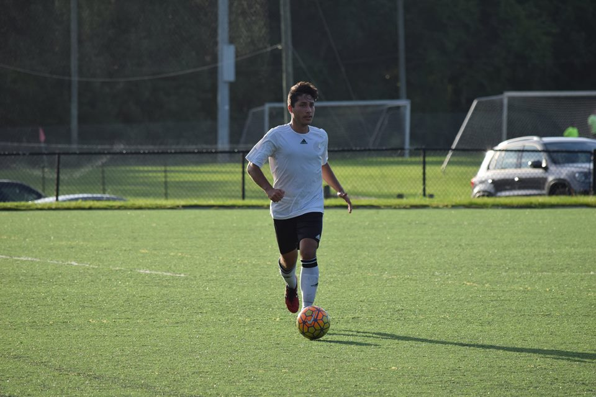

|  |
| --- |
| **Contact info** |
| The best way to contact me is by email or through Dojo.  Email: [farsia@leonschools.net](mailto:farsia@leonschools.net)  Phone: 488-5640 x 136 |

|  |  |
| --- | --- |
| Favorites | |
| Color | Green |
| Season | Fall |
| Team | FSU + Chelsea FC |
| Animal | Wolves + Foxes |
| Author | Shel Silverstein |
| Snack | Fruits + Veggies |
| Game | Apples to Apples |
| Subject | Reading + Math |
| Hobby | Soccer + Teaching |

